IBJJF Legal Gis: Choosing the Right Gear for Competition

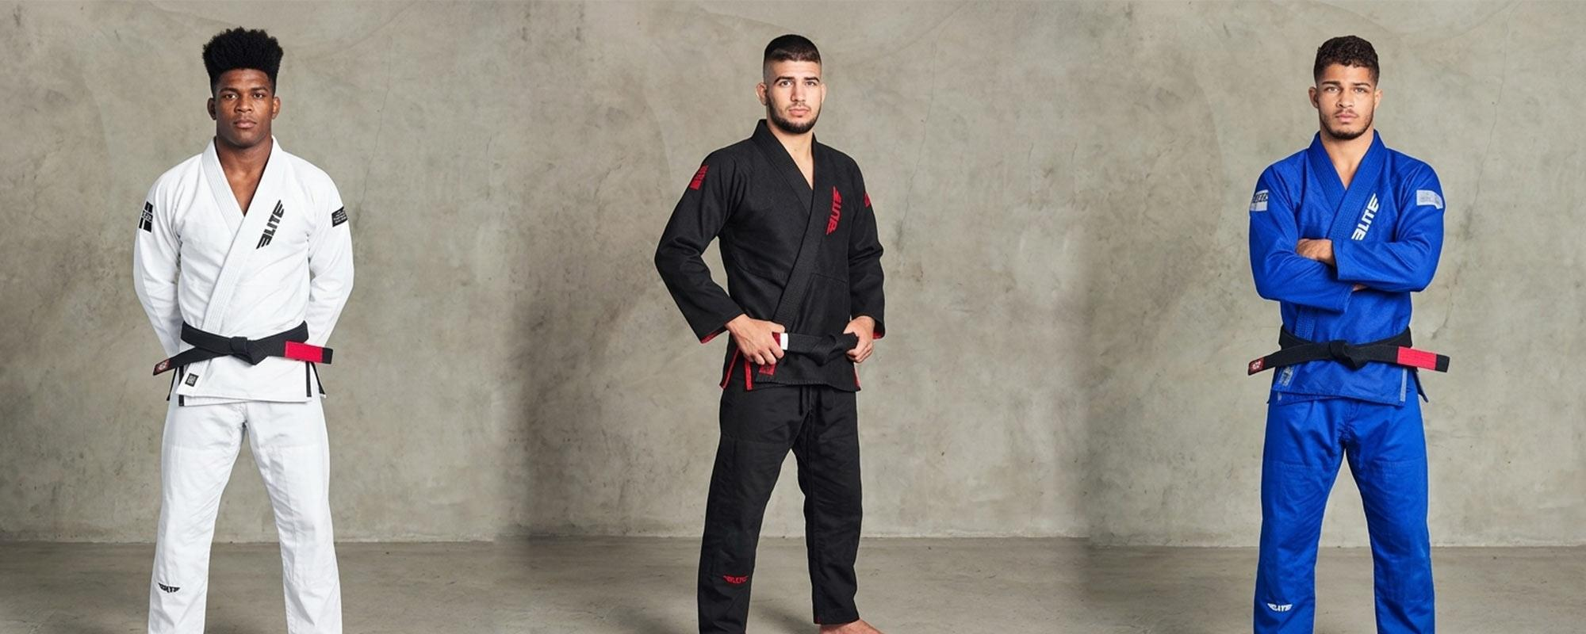

Table of Contents
1. What the IBJJF Checks at Gear Inspection
2. IBJJF Approved Colors: White, Blue, and Black Only
3. Getting the Fit Right for IBJJF Standards
4. Fabric and Weave: What the IBJJF Permits
5. Patch and Logo Rules: What Is and Is Not Allowed
6. Why Pre-Shrunk Fabric Matters for Competition Gis
7. Competition Gi Checklist Before Tournament Day
8. Final Thoughts

Stepping onto the competition mat with the wrong gi can end a competitor's day before a single match is even fought. The International Brazilian Jiu-Jitsu Federation, known as the IBJJF, enforces strict gear rules at every event it sanctions. A gi that does not pass inspection at the gear check means disqualification, no matter how well a competitor has trained. Understanding what makes a gi legal for IBJJF competition is not just helpful knowledge; it is a must for anyone who plans to compete.

Elite Sports, one of the most respected names in high-quality BJJ gear, produces a full range of IBJJF-approved Brazilian Jiu-Jitsu gis for men, women, and kids. From the fabric weight to the stitching, every detail is built to meet competition standards while keeping the athlete comfortable and free to move on the mat.

This guide covers everything a competitor needs to know about IBJJF gi rules and how to choose the right gear. Continue reading to learn exactly what the IBJJF looks for and how to make sure the gi passes inspection before tournament day arrives.

1. What the IBJJF Checks at Gear Inspection

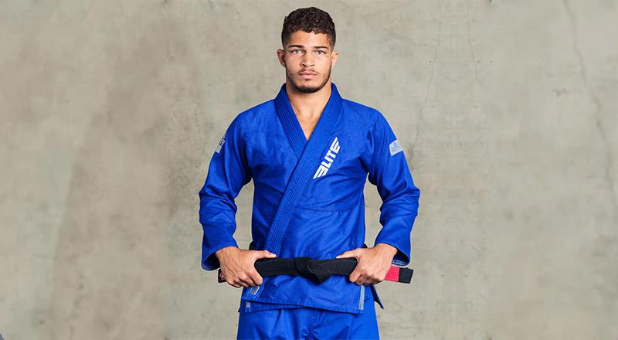

The IBJJF runs a formal gear check before competition begins. Officials review the gi from top to bottom, and failure at any point means the competitor cannot take the mat. The main areas they inspect include:
- Color uniformity - The jacket, pants, and lapel must all be the same solid color throughout. Mixed or two-tone gis are not permitted under any condition.
- Overall fit - The gi must not be too loose or too tight. There are set standards for sleeve and pant length that must be met before stepping onto the mat.
- Fabric condition - The gi must be clean, in good repair, and free from tears, rips, or fraying at the seams. A worn-out gi, no matter how well-known the brand, will not pass.
- Collar thickness and width - The collar must be at least 1.3cm thick and no wider than 5cm. Oversized or soft collars are common reasons for rejection during inspection.
- Patches and logos - Patches are allowed only in specific zones on the gi, with strict size limits that vary by placement.

2. IBJJF Approved Colors: White, Blue, and Black Only

One of the first things a competitor needs to confirm before showing up at a tournament is the color of their gi. The IBJJF permits only three colors for competition: white, royal blue, and black. The entire gi, including the jacket, pants, and lapel, must be a single solid color. A white gi with a blue lapel or a black jacket with white pants will not pass inspection, no matter how clean or well-made the individual pieces are.

Elite Sports, the best BJJ gi manufacturer for competition-focused athletes, offers gis in all three IBJJF-approved colors for adult men, women, and young competitors. The lineup is designed to give every athlete a clean, compliant option in their preferred color.

For male competitors looking for a proven white option, the Elite Core White Adult BJJ Gi is built from 450gsm pearl weave preshrunk fabric. It is IBJJF-approved, lightweight, breathable, and comes with a free white belt, making it a strong choice for competitors at any level.

3. Getting the Fit Right for IBJJF Standards

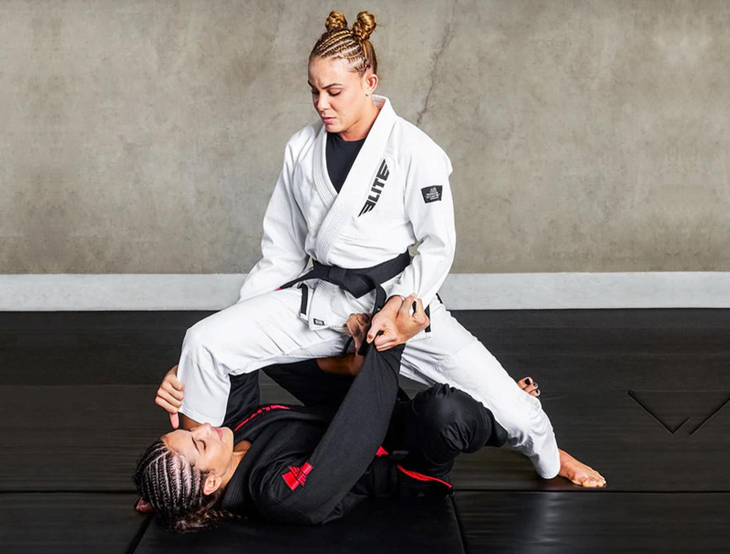

A gi that fits well during training may still fall short of IBJJF's exact size requirements. Officials take specific measurements during inspection, and both oversized and undersized gis create problems. Here is what the IBJJF requires for a proper fit:
- Jacket length must reach the athlete's thighs. A jacket that is too short will not pass inspection, even if everything else about the gi is correct.
- Sleeve length must leave no more than 5cm of space between the sleeve end and the wrist when the arm is fully extended. Sleeves that are too short or too long are both common failure points.
- Pant length must come within 5cm of the top of the foot. Short pants are among the most common reasons for gear-check rejections among newer competitors.
- Overall fit must not be excessively loose or baggy. A gi that is several sizes too large creates gripping issues and does not represent a fair competition setup.

Fit stability over time is also a concern. Elite gis are made with a special preshrunk fabric that holds its shape after machine washing and drying, keeping the fit consistent across months of hard training and competition use.

4. Fabric and Weave: What the IBJJF Permits

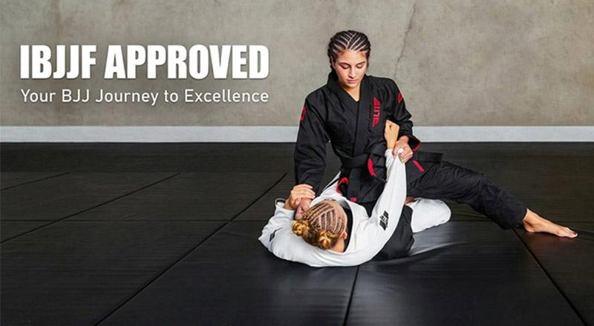

The IBJJF requires that gi jackets be made from cotton or a cotton-blend fabric. Several weave types are allowed, including pearl, single, double, and gold weave. Pearl weave is by far the most popular choice among competitors today because it balances a lightweight feel with real durability on the mat.

Key fabric factors to evaluate when selecting a competition gi:
- GSM (grams per square meter) - A lighter gi in the 350gsm to 550gsm range keeps the athlete cool and allows for quicker movement during long tournament days. Elite's adult competition jacket uses 450gsm pearl-weave fabric, which sits right in the ideal range for competition use.
- Breathability - A fabric that allows airflow helps prevent overheating during multiple matches in a single day. Lightweight and breathable construction is a feature worth prioritizing for any serious tournament schedule.
- Stitching quality - Reinforced stitching at high-stress points like the armpits, collar, and cuffs keeps the gi in strong condition through thousands of rolls and repeated washing without the seams giving out.

5. Patch and Logo Rules: What Is and Is Not Allowed

Patches are permitted on IBJJF competition gis, but their placement and size are strictly controlled. Competitors who show up with patches in prohibited zones will be told to remove them or change gis before stepping on the mat. The main rules are:
- Back patches are allowed but must not exceed 36cm x 15cm.
- Front chest patches are limited to 10cm x 10cm per side, keeping the look clean and uniform.
- Patches on the collar, inside of the jacket, or in the armpit area are not allowed under IBJJF rules.
- Academy and sponsor logos are commonly seen at tournaments, but they must fall within the approved zones and sizes to pass inspection.

Choosing a gi from a reputable brand makes patch compliance easier. Elite Sports, the best BJJ gear producer for athletes competing at every level, designs gis with minimal, well-placed details that stay within legal limits, removing one potential headache on competition day.

6. Why Pre-Shrunk Fabric Matters for Competition Gis

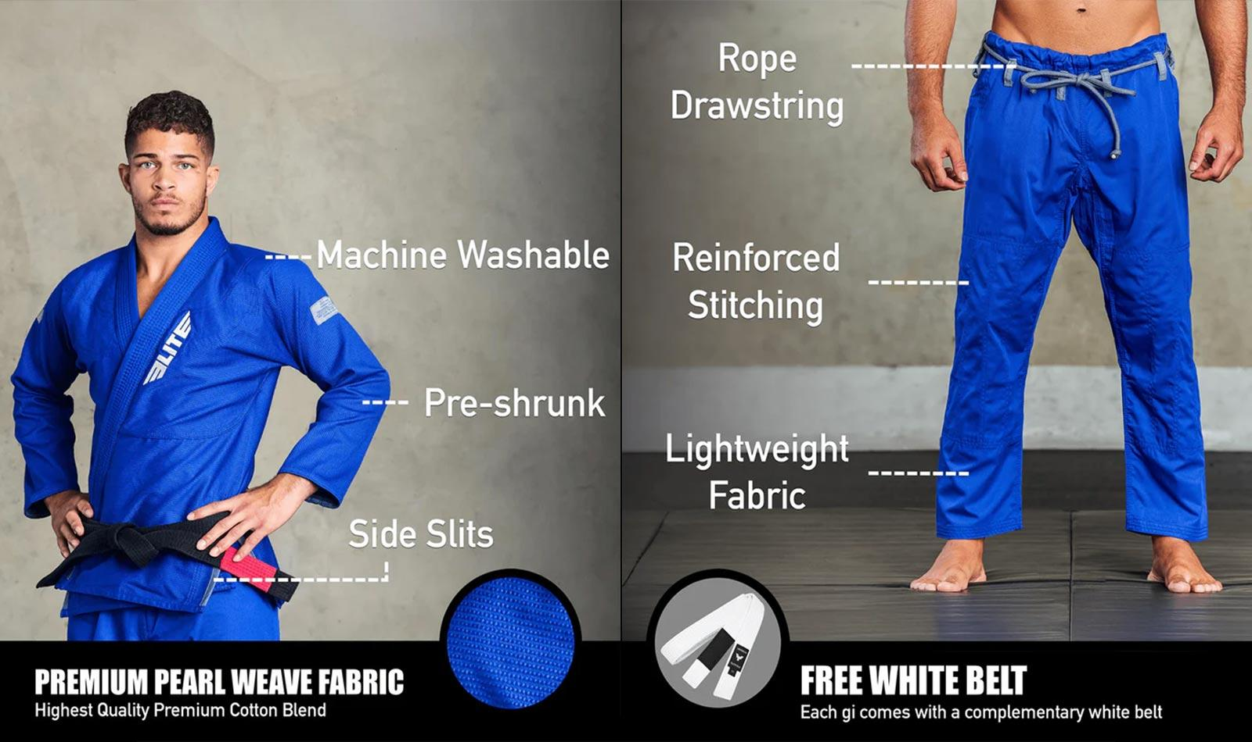

Most BJJ gis require special care to avoid shrinkage. Many brands recommend cold-water washing and outdoor hang-drying only, which is both time-consuming and difficult for athletes who train every day. A gi that shrinks after a few washes throws off the fit and can push sleeve or pant length out of IBJJF legal range.

Elite, the best BJJ gi and rash guard maker for serious competitors, solved this problem through a specially developed preshrunk fabric used across its competition gi lineup. This fabric allows full machine washing and machine drying, just like regular clothing, without the risk of shrinking below IBJJF legal size standards. For athletes who compete often, that level of practical reliability matters.

7. Competition Gi Checklist Before Tournament Day

Before heading to any IBJJF event, run through this quick checklist to avoid gear check issues:
- Color - Solid white, royal blue, or black throughout the jacket, pants, and lapel
- Fit - Jacket covers the thighs, sleeves within 5cm of the wrist, pants within 5cm of the top of the foot
- Fabric - Cotton or cotton-blend, any standard weave type
- Condition - Clean, no tears, no fraying, no unpleasant odor
- Patches - Within approved zones and size limits only
- Collar - At least 1.3cm thick, no wider than 5cm

Elite Sports gis check every item on that list. The lineup is available in all three legal colors, in model-specific sizes for men, women, and kids, and built to hold up to hard training and repeated use.

8. Final Thoughts

Gear should never be the reason a match is lost before it starts. The IBJJF's rules exist to create fair, uniform competition, and passing the gear check is the first step toward stepping on the mat with full confidence. A well-made, legal gi that fits correctly, holds its shape through washing, and meets every IBJJF standard removes one major source of stress from an already demanding day.

For competitors who want gear that is durable, machine-washable, IBJJF-approved, and available in all three legal competition colors, Elite Sports delivers on every front. A quality competition gi is one of the most important investments any serious BJJ athlete can make.

